**ANSWERS OF CASE 2**

**2. Short-Term and Long-Term Biases in the Internal QC Results**

**2.1** The following pictures show one of the analyte’s internal quality control Levy-Jennings graph. Identify if there is any problem and find solutions for each.

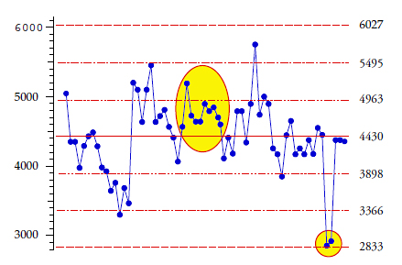Figure A

**2.1.1** The graph A shows…a 10 X rule violation ……and …a random error

Instruction: Write what you would look for in the system to troubleshoot this problem: (write a short answer for each problem)

10 X- a short positive bias and can be due to evaporation or inadequate mixing of the control bottle or failure to recalibrate when the opening of the new reagent

Random error- verify the correct level of control, then rinse the system and repeat the tests.

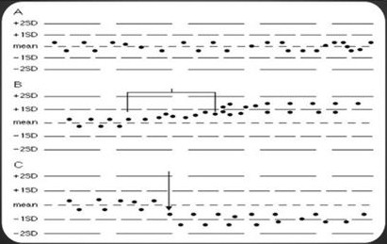

Figure B showing the graphs of A, B, and C

**2.1.2** The graph B shows an upward drift or a trend in B and a downward shift in C.

Instruction: Write what you would look for in the system to troubleshoot this problem (write a short answer for each problem).

**Upward trend** - lack of maintenance in sample cups or light source leading to accumulation of debris or progressive blocking of tubing for the diluent.

**Downward shift** - instability of analyte in the control bottle, deterioration of reagent change of the control bottle, reagent bottle, calibration, partially blocked tubing or aspiration errors.

**2.2** One essential analyte shows a shift in the mean IQC results whenever a new reagent bottle is opened. Other analytes are acceptable. Select what you would investigate in a logical manner to look for the possible problems related to this phenomenon.

1. Records of instrument service
2. Contamination in the control bottle
3. The operator on duty when the shift started and when it goes back to the mean
4. Calibration of the new reagent bottle
5. Lot numbers of the new and old reagent bottles
6. Control bottle changes coinciding with the new reagent change

Write the numbers in logical sequence (for example 1, then 3, then 5).

Answer: 5, then 4. If no problem is found, then 6, if none, then 3

(1 and 2 are not likely)

**2.3** Follow up to the problem discussed in **2.2**; the reagent lot numbers were found to be different. When further investigated, it was confirmed that the operator re-calibrated when the new bottles were opened. Further actions are needed. Select appropriate one(s) in a logical manner.

1. Stop testing for this analyte until the root cause is found
2. Return the control bottles to the manufacturer
3. Check where the cumulative mean and SD limits are set in the Levy-Jennings graph for this analyte and calculate the bias against allowable error.
4. Accept the bias caused by the shift because the result points are still within the control ranges provided in the package insert
5. Investigate how the peers (who are using the same IQC material and the same method) are having the similar problem.
6. Request lot to lot verification data from the manufacturer

Write the numbers in logical sequence (for example 1, then 3, then 5)

Answer: 3, then 5 (or start with 5, then 3), followed by 6.

(1, 2 and 4 are inappropriate actions).